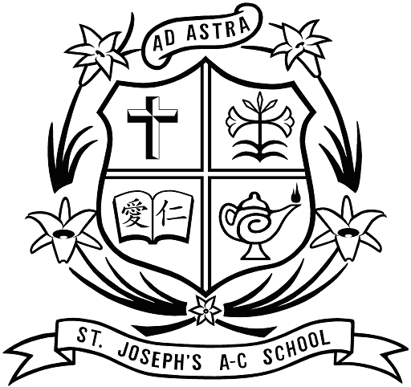
St. Joseph’s Anglo-Chinese School
聖若瑟英文中學

Incorporated Management Committee
法團校董會
Alumni School Manager Election
校友校董選舉

趙其琨教授 (榮譽勳章)
Prof Randy Chiu, MH

Please vote for your Candidate, Prof Randy Chiu
請投趙其琨教授一票

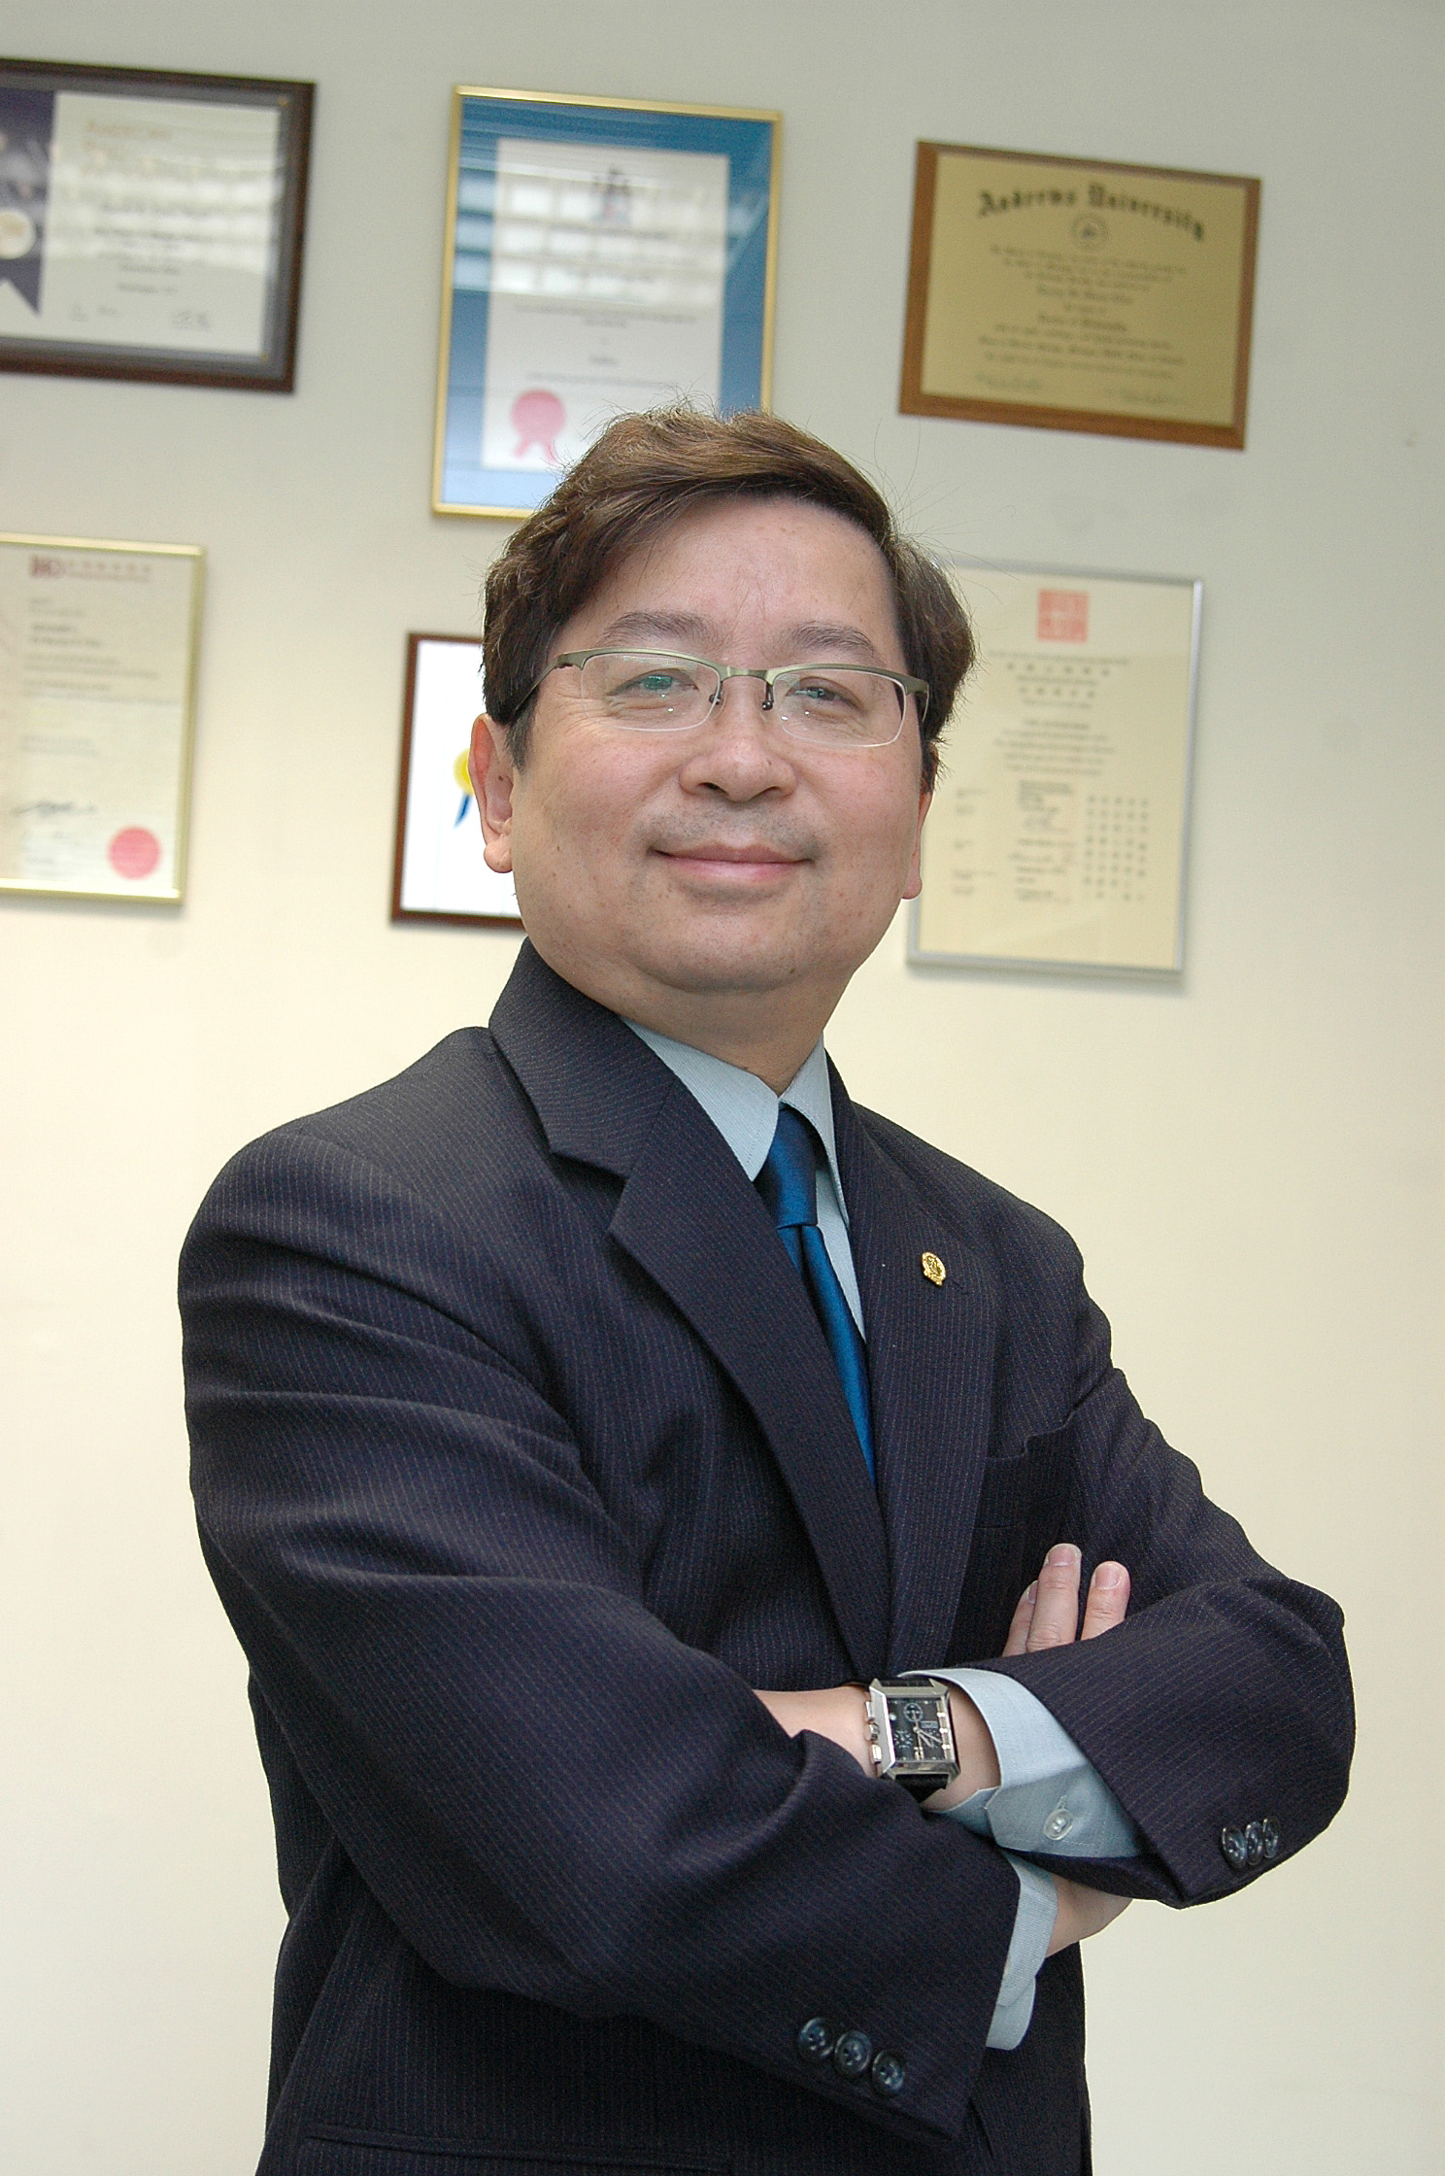

Prof. Randy Chiu 趙其琨教授
Professor Randy Chiu, MH
Dr. Randy Chiu (BA, MA, PhD) left SJACS in 1974 for the US for his further education. He now is a Professor in the Department of Management at Hong Kong Baptist University and holds 10 professional qualifications. He is considered as a leader in HRM education in Hong Kong. He was awarded the Outstanding Human Resource Educational Elite in Greater China Award in 2004 and Outstanding Contribution to HR Award in 2010. In 2012, Prof. Chiu was awarded the Medal of Honour by the HKSAR Government. He has over 100 academic publications and has been given The ANBAR Citation of Excellence Award in 2004 and The Emerald Best Paper Award in 2008.
Prof. Chiu has conducted accreditation exercises for numerous academic programmes and is now a subject matter expert for HKCAAVQ and an academic advisor for a number of local secondary and post-secondary educational institutions. As a management consultant, Prof. Chiu’s clientele include major airlines, hotels, hospitals, and NGOs. Prof. Chiu has served on the board of the Equal Opportunities Commission and other government committees. He is currently a board member of various NGOs, HKBU and SJACS. He has been invited to be a panel judge/adjudicator for various competitions and events. He has given more than 90 talks in the local community and has appeared over 150 times in various print/electronic media.

趙其琨教授 (榮譽勳章)
在一九七四年，趙其琨博士離開了母校到美國深造。他現時為香港浸會大學管理學系教授，並擁有10項專業資格。在香港，他是人力資源管理教育的領導者。趙教授被授予2004年度大中華地區傑出人力資源教育精英的殊榮，以及獲得2010年人力資源傑出貢獻獎。於二零一二年，他更榮獲由香港特區政府頒發的榮譽勳章。他發表超過100篇學術論文，分別榮獲2004年 ANBAR 引文卓越獎和2008年Emerald最佳論文獎。
作為學術素質評審專家，趙教授為香港大專商業教學課程做認證工作；同時亦為香港學術及職業資歷評審局的指導專家，以及本港多家高等和中學教育機構的顧問。身為管理諮詢顧問，他的客戶主要包括航空公司、酒店、醫院及非政府組織。另外，趙教授曾在平等機會委員會服務了6年，亦曾擔任和現任其他非政府組織及大、中和小學校董事會成員，包括香港浸會大學校董會及聖若瑟校董會。他更被邀請出任不同獎勵活動的評委或裁判員。在本港的社區團體中，他進行了超過90場的演講。而且，到迄今爲止，他在各種印刷或電子媒體上也出現超過150次。
JA SM Task Statement

IMC of a school is to manage the school and promote education in the school. For SJACS, the School Manager representing JA in IMC should constantly bear our school motto, Ad Astra, in mind; and therefore, his very important job is to assist IMC develop our younger brothers to live up to this motto in life. He should be a firm believer of the educational ethos and traditions, laid down by our late Bro. Paul Sun, that inspiring our students to drive for excellence.

Education is for a life-time. The School Manager representing JA in IMC should be able to assist IMC bring education closer to the heart and mind of every student. How? Do we do that by enriching their world knowledge, language proficiency, computer competency, and life-saving skills, or by uncovering their potentials and talents? Of course, “yes” to all those. But, most importantly, it is by nurturing and strengthening their courage and love for others, for they can become responsible persons and the fishermen of mankind.

School is a place where people learn. School managers, the principal, teachers, helpers, students, parents and alumni are no difference; we are here to learn of one another; to learn from one another; and learn to love one another. To do so, the School Manager representing JA in IMC should be able to assist IMC ensure the people, systems, the processes, the environment, and the culture working together in a strategic whole. He should play a major role as a go-between nurturing sound working and personal relationships among school administrators, teaching staff and students, by suggesting various initiatives, mechanisms, programmes, projects, and campaigns.

“Old Boys” are our major stakeholders at SJACS. The support and contributions given by alumni of a school are extremely vital to the future success of their mother school, may it be a secondary school or a university. Harvard and HKU are so; La Salle and DBS are so; and so is SJACS. Thus, the School Manager representing JA in IMC should be able to assist IMC build a bridge between students and JA, a super highway transferring success factors of our alumni to our students, transporting community resources to our school, and bringing alumni back to our campus.

With the grace of Heavenly Father, together with our commitment, wisdom, and experience, (I sincerely pray) we will have the right “old boy” for this very important and noble job.
校友會校董工作聲明

學校法團校董會的作用是管理學校及促進學校教育。對於聖若瑟而言，作為法團校董會的校友校董，應時常地緊記本校的校訓－臻於至善；因此，他最重要的工作是協助法團校董會讓年輕的小弟兄來實踐這個人生格言。他應該秉承我們已故校長－孫保祿修士所堅定相信基督教育的精神和傳統，激勵我們學生，使他們邁向卓越。

教育是終身的。身為校友校董，應該能夠協助法團校董會為每位學生帶來更貼心的教育。如何？那我們只要豐富他們的世界知識，增強他們的語言能力、電腦技能和求生技能，或者透過發掘他們的潛能和才華就能達到嗎？當然，以上所說的都是。但是最重要的，莫過於通過對他們的培育，加強他們的勇氣，以及對別人的關愛，使他們能夠成為富有責任感的人。

學校是一個讓人學習的地方。不論是校董，校長，教師，助手，學生，家長和校友都沒有什麼區別；在這裡，我們學習彼此認識，彼此相愛和相互學習。要做到這一點，校友校董應當能夠協助法團校董會以確保人員、系統、程序、環境和文化能夠互相協調。再者，他必須扮演一個中間人的角色，就是通過提出各種倡議、機制、方案、項目和活動，從而建立有效的工作環境和孕育行政人員、教學人員和學生之間的良好關係。

在聖若瑟英文中學，「老子」就是我們主要的持份者之一。無論是一所中學或大學，對於母校未來的成功，該學校的校友所給予的支持和貢獻是極其重要。哈佛大學和香港大學是如此；喇沙和男拔也是如此；所以，聖若瑟亦不例外。因此，校友校董應當能夠協助法團校董會在學生和校友之間建立橋樑，使其能夠像駕駛在超級高速公路般的速度，將我們的校友成功的要素轉移至我們的學子身上，為我們的學校運送社區資源，以及令校友重回母校。

緊靠天父的恩典，以及我們的承諾、智慧和經驗，（我衷心地祈禱），我們將有合適的「老子」為這非常重要和崇高的工作而奮鬥。

